***Sohaib Sarosh Shamsi***

***21K-3278***

Q1. Write a program to implement the exchange or swap the values of 3 variables{a,b,c}. To implement this, you need to write a function called swaped().

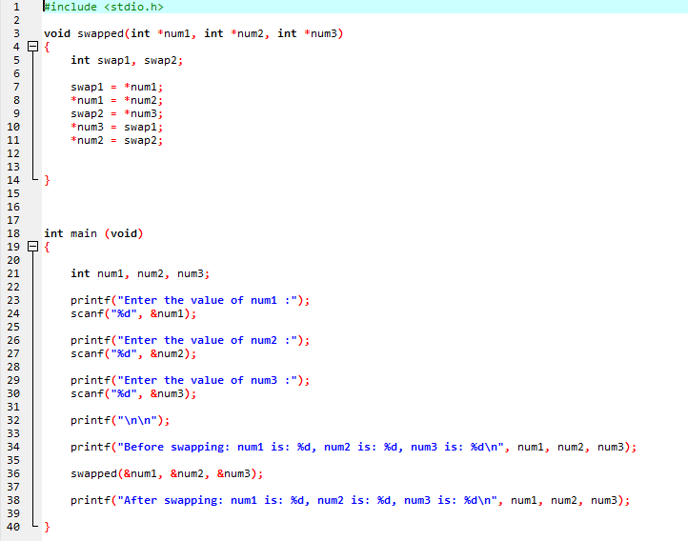

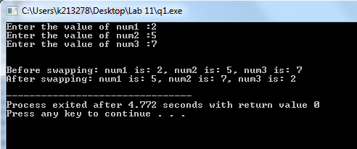

Q2. Write a program that calculates the sum of all the elements in array using pointers

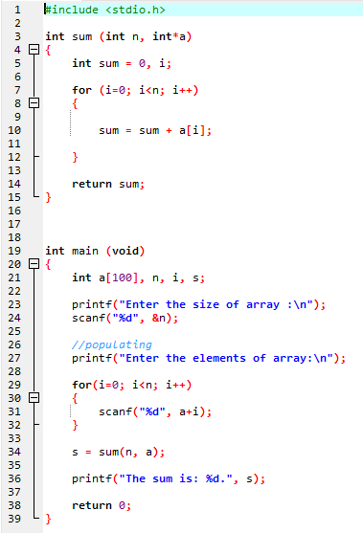

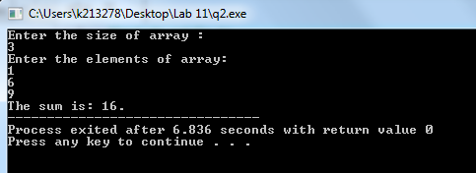

Q3. Write a program to find the min and max from an array using pointers.

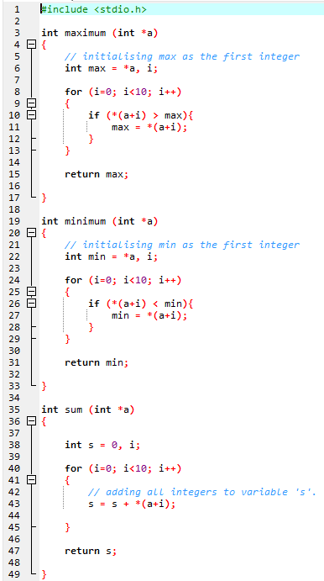

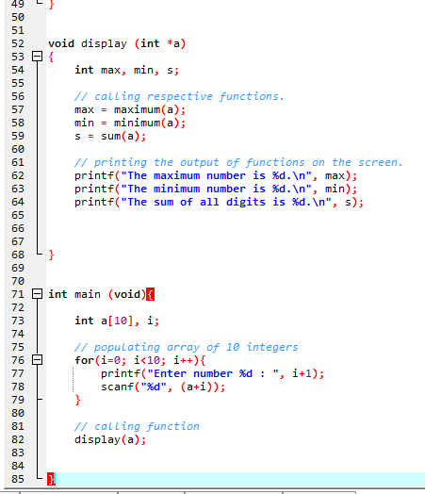

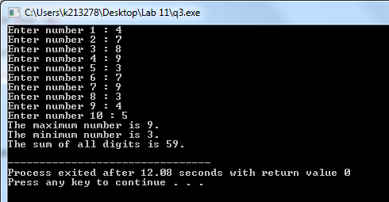

Q4. Write a program that implements the function(WordCount).

int *WordCount(char *Text, int *size);

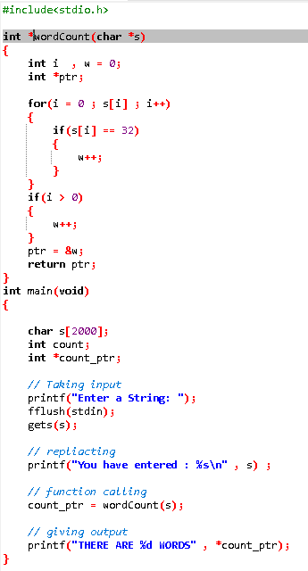

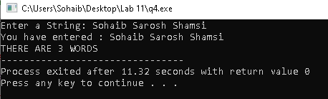

Q6. Write a program to find middle element of the array using pointers.

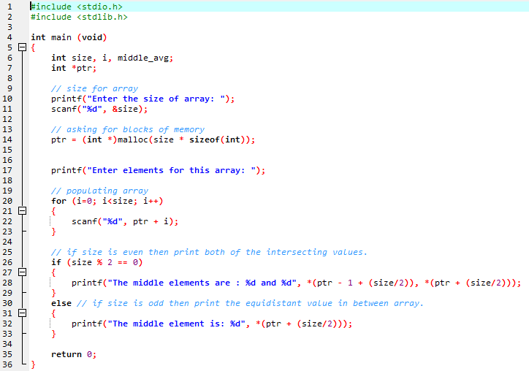

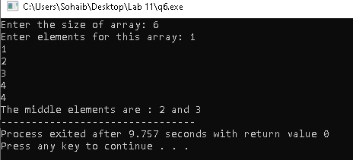

Q7.You need to implement the the following 2 struct.

struct Student{}; struct Register{};

Student contains attribute StudentId, FirstName, LastName, cellno, email.

Register contains attribute CourseId, CourseName.

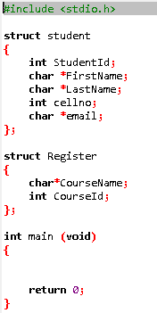

Q8. Using question 7, Now you need to inherit the Register struct in Student struct. It means that student struct holds the variable of Register struct variable. After that you need to take input for 5 students and then print them

[Hint: Declare array of struct Student std[5]; for 5 students ]

